My 2016 summer in Thailand!
It’s been more than a week since the student exchange program finished and I came back Vietnam to study. What I’ve been felt is nothing much special until I realize that there are much more interesting things to talk about this trip. And now I’m writing it down.
Back to one month ago, we were all 4th year students had just finished our semester examination. All, 8 of us, were exciting about the trip but we wavered a little bit because spending not a little money, afraid a little bit of the first time going and studying abroad.
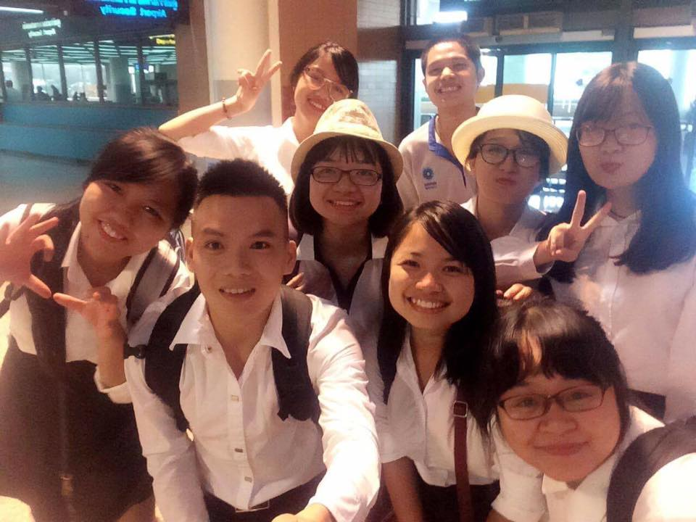
Pi Kay picked us up at the airport
All of those hesitations and anxiety disappeared immediately when we arrived in Bangkok. Welcoming us was Pi Kay (Mr. Amporn Songkasiri) with his friendly smile and enthusiasm. The next day we had a welcoming lunch & a cozy meeting with the teachers there, we were also taught about Thai Culture and languages. Learning those new things gave us amazing small tips when we were in Thailand. All of us were very happy while walking on the way to school or on any street in Thailand seeing the people there very friendly, they are always with the smile on their face, and we also did the same. Then every day we smiling said “sawadee kha” to the teachers, to the guards at the faculty of Pharmacy, to the sellers on the streets . Thai people are so friendly and they are willing to help you when you’re in troubles. Those things make us feel like at home when we were abroad, and I know more about Thai people, and one reason makes the travelling industry in Thai developed.
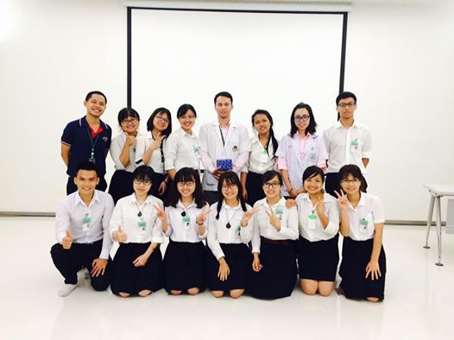
After class about Applied Thai Traditional Medicine at Siriraj Hospital
In following days, we studied many lectures, mainly about Health Technology Assessment, Thai Health Insurance system, Nutraceuticals and Toxicology… Those lectures are just an overview about Thai health system for us, but they let us know about the difference between the two, Vietnamese and Thai Health system, and how government cares about the residents. We also fortunately had a field trip to go to center of Applied Thai Traditional Medicine at Siriraj Hospital. That was a wonderful hospital I couldn’t describe by words, it amazed me might because of it was such a good hospital I’ve never seen before. My friends also said that It’s like a resort with convenient services. At that time I also thought about the progress of Health Service in Vietnam, and we, as pharmacy students, what could we do to contribute our best to the Vietnamese health system? The study program gave us both the knowledge and motivation to be better in our field in the future.
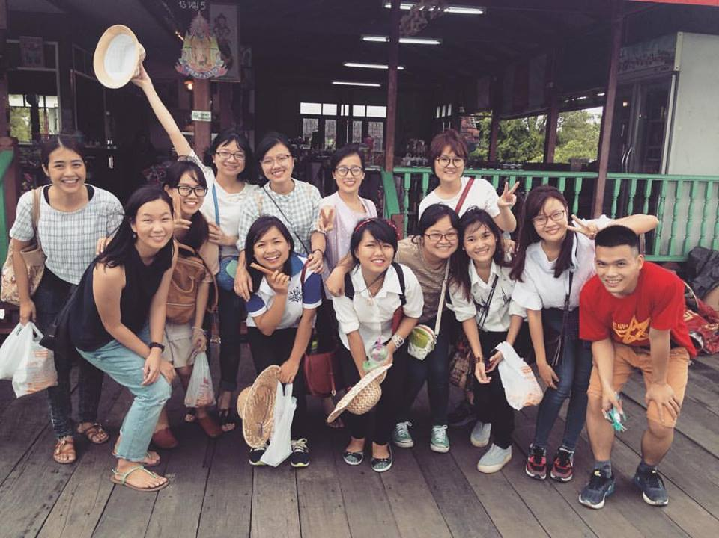
Visited Koh Kred Island with Thai Friends
The second thing except study I want to talk about is Thai culture and experiences in Thailand with friends. We were very lucky to know Thai students, who already joined the student exchange program in our University – HUP in 2015, they were very kind to us, and helped us a lot during the trip. We went to some University campus together and visited the libraries. Those libraries are very nice ^^. They are very convenient and there is such a huge source of books and academic materials for students and teachers. We also went to some museums, where we got to know about Thai culture, and the progress of the country. We also understood why the Thai people really love their kings and we knew what their king contributed to their country and people with their hearts. Thai friends took us to some beautiful places like Rose Garden Riverside, Koh Kred Island… many shopping centers … In Thailand, we met Vietnamese student from Hanoi National University as well. We travelled and had fun together. We talked about each other’s university. This study course is not also about study, as I said. We also learned a lot from each other and experienced some situations just when you’re abroad. It brings me not only knowledge, experience, but lovely friendship as well.
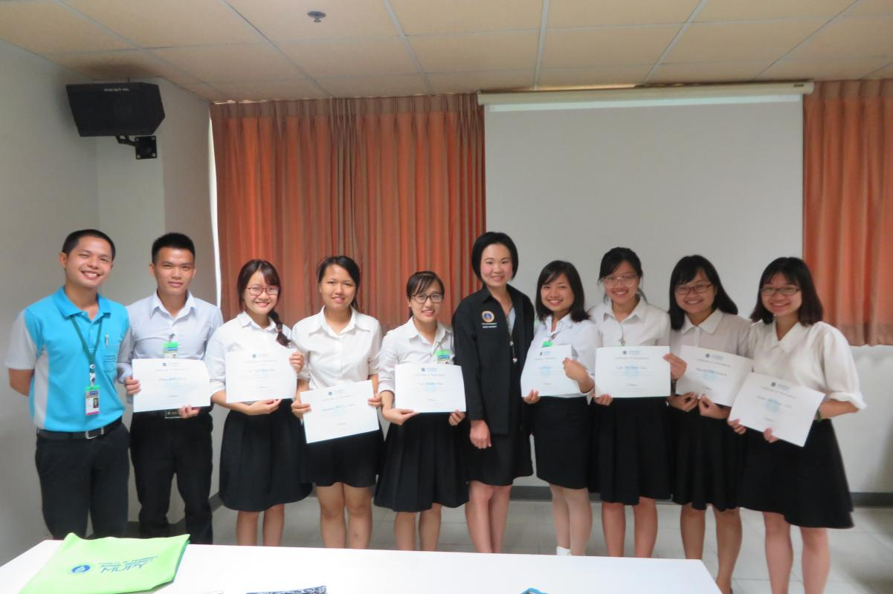
After presentation – Last day at Mahidol University
This trip opens before our eyes a new sight about many things, study, pharmacy, culture and the life abroad. It also motivates the students like us to put more effort on our study to be good components in our field, pharmacy. I want to say thanks a lot to my university, gave me the chance to join this study program, thanks to my teachers , my family and friends who supported me a lot in this trip . This student exchange program is useful, beneficial for me, for us, and I think it’ll be good for the students in HUP. I hope that there will be more and more programs like this and there will be more opportunities for students to broaden their knowledge and experience.
In brief, this was an amazing trip!!
Love
Cao Thị Minh Đức
M1K67-HUP

